Step 5. Body
Within this section of the Install Assistant, you will be calibrating the IMU sensor contained within the EC520. This sensor monitors the pitch and roll of the machine body during operation. This calibration also assists with locating the Center of Rotation of the excavator.
1. Select Body Calibration from the Install Assistant Menu
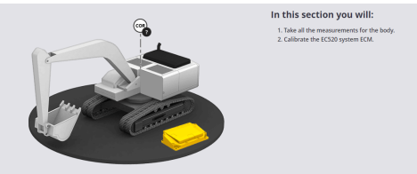
2. Position the machine as shown on-screen. The machine must be on stable
ground. Select Begin Reading and wait for the STOP icon to disappear. You will
rotate the body counter-clockwise through 360 degrees. Make sure to rapidly
increase and decrease speed at the start and end of the calibration step.
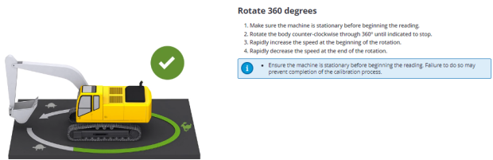
3. Once this step is complete, the system will show a green checkmark and allow
navigation to the next step.
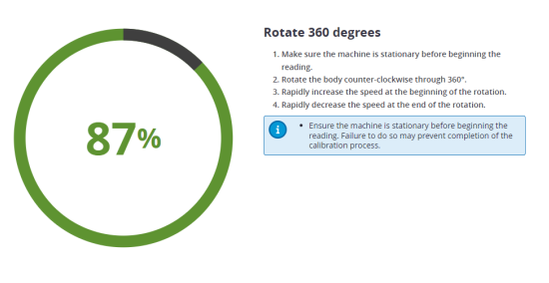
4. In the next step, the machine body will be moved in steps while pausing in
multiple different locations. The machine must be placed on a slope of 4
degrees or more for this step to be successful.
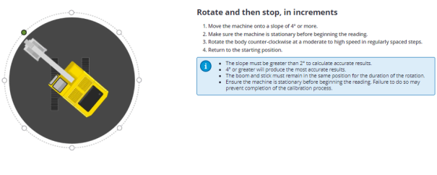
5. Select Begin Reading and follow on-screen prompts and move the machine
counter-clockwise into the desired positions. The machine should be rotated at
a moderate to high speed between steps.
6. Select Finish and Save once the calibration is complete

